1. It’s very important to understand how database **collections** and **documents** are related.
2. You have one or more databases on **database server**. Each database can hold one or more collections (tables in SQL database) and each collection can have multiple documents.
3. Document is really **data pieces** we’re storing in our database.
4. They (Database, Collection, and document) are all created automatically when you start storing data. That is really convenient but later in the course we will also learn a way of explicitly creating new collections which allows you to configure them a bit further but this is a cool feature which makes getting started super simple.
5. 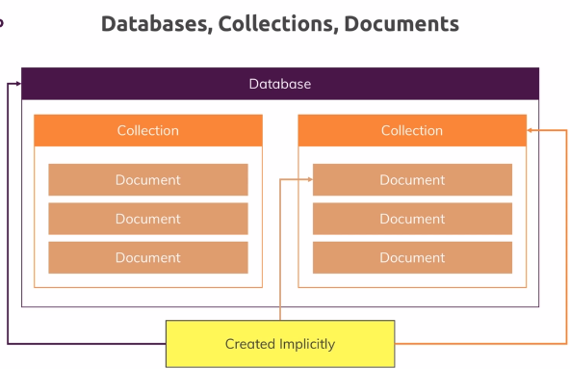
6. Let’s bring up mongodb shell and connect with it using shell and see how to store data in there and which kind of data that is.
7. 
8. 
9. **Command to start mongodb server and changing the default port**:
10. 
11. 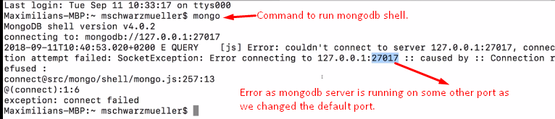
12. **Command**🡺 mongo –port 27018